Fall Detection Systems in Public Spaces
Eden Amram, Ziv Shamli

Introduction
According to the World Health Organization (WHO), falls are the second leading cause of unintentional injury-related deaths worldwide. Each year, the WHO estimates that approximately 37.3 million individuals experience falls severe enough to require medical attention, underscoring the substantial global health burden associated with this issue. National-level data support this observation: a 2024 study titled Clinical trauma severity of indoor and outdoor injurious falls requiring emergency medical service response reported that in the United States alone, 1,854,909 fall incidents in 2019 required emergency medical services (EMS).
The study found that nearly 85% of fall events occur indoors, however, a meaningful proportion also occurs outdoors: in parks, sidewalks, and roadways. These outdoor environments introduce additional challenges such as uneven terrain, varying lighting conditions, environmental obstacles, and the presence of other people in the background. Such factors create complex real-world scenarios that significantly complicate fall-detection tasks.
A recent systematic review, Deep Learning for Computer Vision based Activity Recognition and Fall Detection of the Elderly (2024), further highlights major limitations in current research. Most existing fall-detection models achieve high performance only in controlled indoor environments, while their accuracy deteriorates in uncontrolled settings such as outdoor areas, crowded spaces, and low-light conditions. The review emphasizes that nearly all publicly available fall-detection datasets are collected in laboratory-controlled indoor environments, characterized by stable lighting, fixed camera positions, clean backgrounds, and scripted fall scenarios performed by healthy individuals. As a result, current datasets lack the visual diversity necessary for robust real-world generalization.
Additionally, the review notes that many proposed deep learning architectures are computationally heavy, making them impractical for real-time deployment, especially on resource-constrained edge devices. In real-world applications, fall-detection systems must operate with minimal latency to provide timely alerts, which requires lightweight and efficient models capable of real-time inference without sacrificing accuracy.
Developing such systems also requires large, diverse, and realistic datasets, covering a wide range of lighting conditions, backgrounds, camera angles, human appearances, and dynamic environments. However, collecting large-scale real-world fall data manually is impractical due to safety constraints, time limitations, and high costs. Consequently, recent research highlights the growing need to leverage generative models, such as diffusion-based architectures, to synthesize realistic and diverse fall-related images. These generative techniques can significantly augment existing datasets, increase visual variability, and improve the generalization and robustness of fall-detection models in real-world scenarios.

Related Works
There are various types of generative models for creating realistic images, including Text-to-Image models and models designed for integrating objects into existing images (Object Compositing). These models enable the generation of new, visually accurate images, whether based on textual descriptions or through object integration, while maintaining consistent details and a coherent scene. In this study, generative models were used to create realistic images of falls in public spaces, with the aim of producing data for training and evaluating fall detection models.
A comparative study conducted in “Perception and Evaluation of Text-to-Image Generative AI Models” examined the performance of four leading models: OpenAI’s DALL-E, Google’s Imagen, Stable Diffusion, and GROK AI. The study combined quantitative evaluation using metrics such as FID, SSIM, and PSNR with human evaluation in a survey of 28 participants, aiming to assess the perceived realism of the generated images.
DALL-E, based on a Transformer architecture with VQ-VAE-2 for creating a discrete latent space, showed high performance in both quantitative metrics and user evaluation, demonstrating the ability to generate diverse and complex images. Imagen, Google’s closed diffusion model, excelled in producing photorealistic and accurate images, with participants rating its outputs as nearly as realistic as real photographs. In contrast, open models such as Stable Diffusion and GROK showed lower performance, with higher FID scores and lower perceived realism.
In the context of object integration into existing images, the study by Song et al. (2024) introduced IMPRINT, an innovative Generative Object Compositing framework. The model focuses on preserving object identity and harmonizing with the background, applying a two-stage strategy: the first stage involves Context-Agnostic ID-Preserving Pretraining using a DINOv2-based encoder to learn view-invariant representations and preserve instance-level details; the second stage performs Compositing & Harmonization with fine-tuning of the Stable Diffusion UNet, including integration of the object embedding in cross-attention layers and additional techniques to improve harmonization and control object shape.
Experiments with IMPRINT showed superior performance compared to existing models such as Paint-by-Example, ObjectStitch, and TF-ICON. Quantitative metrics indicate significant advantages: FID = 16.45, indicating high realism; CLIP-score = 96.19, reflecting optimal object identity preservation; DINO-score = 94.71, showing precise visual detail retention; and DreamSim = 0.083, indicating close alignment with perceived realism by users. In a user survey, 73–86% preferred IMPRINT in terms of object fidelity and image realism.
From the analysis of the findings, several key trends can be identified: first, industrial Text-to-Image models (DALL-E, Imagen) exhibit high realism and diverse image generation capabilities; second, Object Compositing models allow realistic integration of objects while preserving their identity and scene consistency; third, combining quantitative evaluation with human assessment is essential for evaluating generative model performance; and finally, there is a significant gap between large industrial models and open models, particularly regarding realism and visual detail preservation.
There are different approaches to human fall detection, with some methods processing each frame individually, while others analyze a sequence of frames to detect abnormal movement patterns. The choice of approach affects not only the detection accuracy under challenging conditions, such as low lighting, complex backgrounds, or partial occlusions, but also the processing speed, which is critical for real-time applications on edge devices.
Zhang et al. (2022) in “Visual Surveillance for Human Fall Detection in Healthcare IoT” present a visual monitoring system designed for integration into healthcare IoT infrastructures. The system operates in two main stages: first, it tracks the person using motion detection and gait analysis. Second, it analyzes body posture by calculating angles, curvatures, and rapid changes in body position. The system uses a model such as OpenPose to detect body keypoints in each frame, which are then connected to form a skeleton representation. From the skeleton, features such as body angles, leg angles, and height–width ratio are computed to detect falls and abnormal postures. Advantages of this approach include robustness to background noise and partial occlusions, low dependency on color or texture, and high accuracy under good lighting conditions (up to 98.4%). Limitations include poor performance in low-light environments, high computational requirements (GPU), and the risk of false alarms, particularly in complex scenes.
Zi et al. (2023) in “Detecting Human Falls in Poor Lighting: Object Detection and Tracking Approach for Indoor Safety” focus on fall detection in low-light environments. The system includes preprocessing to isolate the body and reduce background noise, feature extraction using an object detection model (YOLO) to learn the appearance and current posture of the person in each frame, and a temporal model based on LSTM/GRU that analyzes a sequence of frames to understand movement: standing → losing balance → falling. Advantages of this approach include understanding movement over time, noise reduction, and higher accuracy compared to single-frame models. Limitations include higher computational requirements, the need to analyze multiple frames, and sensitivity to occlusions, for example, when the person is partially hidden behind furniture, accuracy decreases.
Nabizade et al. (2025) in “Fall Detection Using LBFD-Net: A Novel CNN-Based Architecture” introduce a lightweight CNN called LBFD-Net for real-time fall detection. The model was trained on a combined dataset of 18,316 labeled images from four different datasets, balanced between fall and non-fall images. The architecture includes convolutional and residual blocks, global average pooling to create a compact feature vector, and a fully connected layer with a sigmoid output to estimate the probability of a fall. The model achieved high accuracy (99.59%), low resource requirements, and was both lighter and more efficient compared to classical models such as AlexNet and LeNet. Limitations include processing single frames only (without temporal information), training only in controlled environments, and no training on low-light or outdoor images. In our study, we plan to use this network due to its high accuracy, lightweight design, and real-time capability on edge devices.
Research Question
How does training a fall detection model on images with varying lighting conditions (including darkened images) , indoor environment and crowded space affect the model’s accuracy, sensitivity, and robustness in detecting falls under different lighting environments?

Datasets:
- URFD
The dataset contains 289 fall images and 363 non-fall images (normal activities). The images were extracted from video sequences captured with RGB and Depth (Kinect) cameras. All samples were recorded indoors under bright and controlled lighting conditions.
Link: URFD Dataset
- UP-Fall
The dataset includes 17 participants (9 males, 8 females) aged 18–24. Each participant performed 11 activities (6 daily activities and 5 falls), each repeated three times. All recordings were captured with RGB cameras under bright and controlled lighting conditions.
Link: UP-Fall Dataset
- Le2i
The dataset contains 208 images from 13 different scenes. Half of the images (104) depict falls, and the other half (104) show normal activities. Images were captured in various environments (living rooms, meeting rooms, corridors, etc.) and from different angles. Lighting conditions were bright and controlled.
Link: Le2i Dataset
- MultiCam
The dataset includes 24 video clips of falls as well as videos of normal activities. Recordings were made simultaneously with 8 different cameras to capture events from multiple angles. All recordings were conducted under bright and controlled lighting, with variations in lighting angles only.
Link: MultiCam Dataset

Methodology
This research consists of two main phases.
Phase 1 focuses on evaluating generative models and creating a synthetic dataset representing public-space fall scenarios, addressing the lack of real-world outdoor fall data.
Phase 2 evaluates the performance and generalization capabilities of LBFD-Net under different training conditions, using both real laboratory data and synthetic data.

Phase 1: Generative Model Evaluation and Synthetic Dataset Creation
Due to the lack of publicly available real-world fall datasets collected in outdoor or crowded environments, this study first focused on generating synthetic fall images using advanced generative AI models. The goal was to identify the most suitable Text-to-Image and Image-to-Image models capable of producing realistic fall and non-fall scenes in public spaces such as streets, sidewalks, and parks.
Two evaluation tracks were conducted:
Track A: Text-to-Image (No Reference Image)
Each model generated 10 images from the same textual prompt describing a fall event in a public environment. The generated images were evaluated using no-reference image-quality metrics:
- NIQE – Measures naturalness and deviations from natural scene statistics
- BRISQUE – Evaluates spatial image quality without requiring a reference
- MA Score – Estimates aesthetic quality based on visual composition
The model achieving the best overall combination of realism, aesthetic quality, and low distortion was selected.
Track B: Image-to-Image (With Reference Image)
In this track, each model generated 10 images based on a single reference image representing a public-space background. These images were evaluated using reference-based metrics:
- KID – Measures distribution similarity between generated and real images
- PSNR – Evaluates image fidelity
- SSIM – Measures structural similarity and preservation of details
The best-performing model was selected for generating additional synthetic samples.

Synthetic Dataset Generation
Using the top-performing Text-to-Image and Image-to-Image models, a synthetic dataset of 350 labeled images was created. These images depict fall and non-fall scenarios in diverse public environments, with variations in:
- Background complexity
- Lighting conditions
- Camera angles
- Human poses and crowd presence
All synthetic images were manually labeled and used in Phase 2 for training and testing.

Phase 2: Fall Detection Using LBFD-Net
Phase 2 investigates how different training data compositions—laboratory-only, synthetic-only, and hybrid—affect the performance of LBFD-Net, a lightweight CNN designed for fast real-time fall detection.
Three independent LBFD-Net models were trained, each using a different training dataset.
Training Dataset Construction
To systematically evaluate the impact of real and synthetic data, three training datasets were prepared:
Dataset A - Laboratory-Only Training Set
Contains only real fall and non-fall images captured under controlled indoor conditions.
Characteristics include:
- Stable lighting
- Fixed camera position
- Simple, uncluttered backgrounds
- No crowd or complex outdoor features
This dataset represents the traditional scenario commonly used in fall-detection research.
Dataset B - Synthetic-Only Training Set
Contains only synthetic public-space images generated in Phase 1.
These images include:
- Diverse backgrounds and environments
- Variable illumination
- Multiple people in the background
- Naturalistic fall poses
This dataset simulates uncontrolled outdoor conditions where collecting real fall data is impossible.

Dataset C - Hybrid Training Set (50% Laboratory, 50% Synthetic)
A balanced combination of real indoor images and synthetic public-space images.
The purpose of this dataset is to integrate the benefits of both domains realistic textures and varied environments, potentially, improving generalization.

Unified Test Set for All Experiments
All three LBFD-Net models were evaluated using the same fixed test set to maintain consistency and fairness.
The test set includes:
1. Real Laboratory Test Images
Unseen real indoor images are used to measure in-domain performance.
2. Synthetic Public-Space Test Images
Unseen synthetic images used to evaluate cross-domain generalization to environments that mimic real-world public scenes.
Because no real outdoor fall datasets exist, the synthetic test images serve as the only available proxy for evaluating performance in public-space environments.
Training Procedure
LBFD-Net was trained independently on each of the three training datasets using an identical training pipeline:
- Image resizing and normalization
- Batch size : 16
- Optimizer: Adam
- Loss: Binary cross-entropy
This design ensures that differences in performance are caused only by the training data composition.

Evaluation Metrics
Each LBFD-Net model was evaluated using several standard performance metrics:
Classification Metrics
- Accuracy – overall correctness
- Precision – proportion of correctly identified falls
- F1-Score – harmonic balance between precision and recall
- Confusion Matrix – distribution of predictions across classes
Curve-Based Evaluation
- ROC Curve – relationship between TPR and FPR
- AUC – threshold-independent performance indicator
These metrics allow a comprehensive comparison between all three training strategies.

Result

Results – Stage 1: Evaluation of Text-to-Image Models
In this stage, generative Text-to-Image models were evaluated to select the most suitable model for generating realistic images of falls in public spaces, without the use of a reference image. Three diffusion-based models were examined: Stable Diffusion v1.5, Stable Diffusion XL with VAE, and Kandinsky 2.2.
Each model generated 10 images based on the same textual description of a fall scenario in a public environment.
Image quality was evaluated using no-reference metrics: NIQE, BRISQUE, and MA Score. In general, the literature considers a high-quality image to be characterized by a NIQE value below 3, a BRISQUE value below 20, and an MA Score close to 10, which respectively indicate realism, spatial quality, and visual aesthetics.

Quantitative Results

Models | ↓NIQE | ↓BRISQUE | ↑MA Score
Stable Diffusion v1.5 | 3.271 | 17.474 | 5.862
Stable Diffusion XL with VAE | 3.764 | 15.504 | 5.789
Kandinsky 2.2 | 4.495 | 36.117 | 6.094

Visual Results
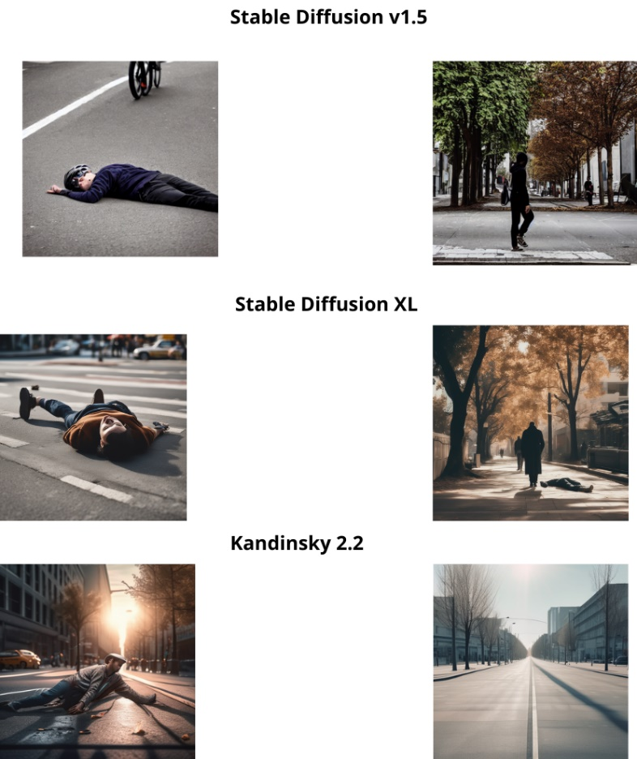

Results Analysis
The results indicate that each model exhibits distinct quality characteristics.
Stable Diffusion v1.5 achieved the lowest NIQE value, indicating relatively good alignment with the statistical properties of natural images. However, its BRISQUE value is higher than that of Stable Diffusion XL with VAE, suggesting slightly lower spatial quality.
Stable Diffusion XL with VAE achieved the lowest BRISQUE value, which falls below the commonly accepted quality threshold (20), indicating high structural stability and reduced local distortions. Although its NIQE value is slightly higher than the ideal threshold, it still reflects a good level of realism, especially given the complexity of the generated public scenes. The MA Score indicates a reasonable and stable level of aesthetic quality.
In contrast, Kandinsky 2.2, despite achieving the highest MA Score, exhibited NIQE and BRISQUE values that are significantly higher than the accepted ranges. This indicates reduced realism and spatial quality, as well as the presence of visual artifacts.

Model Selection
Based on the combined evaluation of the metrics, particularly the fact that Stable Diffusion XL with VAE meets the accepted quality thresholds in the BRISQUE metric and the balance it demonstrates between realism, structural stability, and aesthetic quality, this model was selected as the Text-to-Image model for generating the synthetic data in the subsequent stages of the study.
This choice is especially suitable for the current application, where preserving human body structure, realistic falling postures, and complex backgrounds that simulate public environments is of high importance.

Results – Stage 1: Evaluation of Image-to-Image Models
In this stage, generative Image-to-Image (img2img) models were evaluated with the goal of generating realistic images of falls in public spaces while preserving the structure of the original scene through the use of a reference image.
The models were required to insert a fall scenario into an existing scene while maintaining background characteristics, lighting conditions, and spatial structure.
The evaluated models were: Stable Diffusion v1.5, Stable Diffusion XL + VAE, Masked Stable Diffusion XL, and ChatGPT-5.
Each model generated 10 images based on the same reference image.
Image quality was evaluated using reference-based metrics: KID, PSNR, and SSIM.
Lower KID values indicate higher similarity to the distribution of the original images, while higher PSNR and SSIM values indicate better preservation of visual details and scene structure.

Quantitative Results

Models | ↓KID | ↑PSNR | ↑SSIM
Stable Diffusion v1.5 | 0.616 | 8.674 | 0.212
Stable Diffusion XL + VAE | 0.0283 | 19.810 | 0.659
Masked Stable Diffusion XL | 0.037 | 19.365 | 0.638
ChatGPT 5 | 0.405 | 9.202 | 0.272

Visual Results
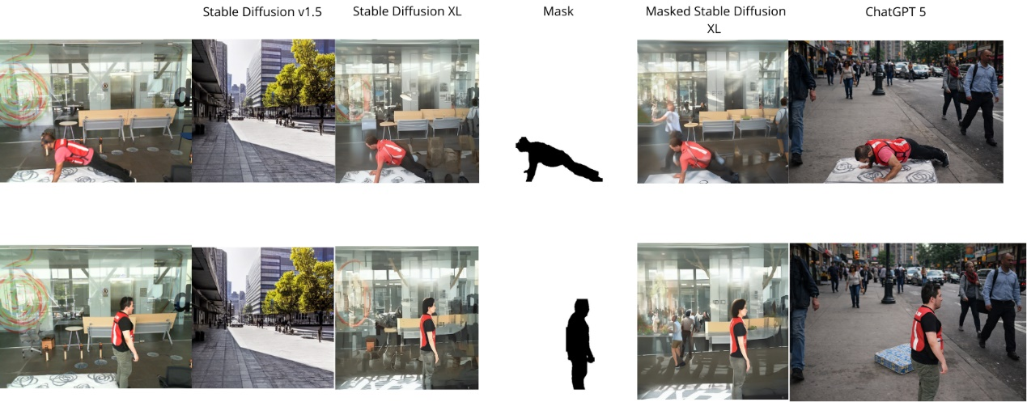

Results Analysis
The results reveal a clear performance gap between the evaluated models.
Stable Diffusion XL + VAE achieved the lowest KID value, indicating exceptionally high alignment with the distribution of the original images. In addition, this model achieved the highest PSNR and SSIM values, reflecting strong preservation of scene details, background structure, and overall visual consistency with respect to the reference image.
The Masked Stable Diffusion XL model exhibited very similar performance, with slightly lower PSNR and SSIM values and a slightly higher KID value. These findings suggest that the use of masking contributes to preserving specific regions of the scene, but does not result in a substantial overall quality improvement compared to the VAE-based version.
In contrast, Stable Diffusion v1.5 and ChatGPT-5 exhibited significantly higher KID values alongside lower PSNR and SSIM values. This indicates a notable deviation from the reference image and reduced preservation of spatial structure and visual details. These models struggle to produce images that meet the realism and reliability requirements necessary for generating high-quality synthetic data.

Model Selection
Based on consistent and superior performance across all three metrics, Stable Diffusion XL + VAE was selected as the Image-to-Image model for generating synthetic data in the subsequent stages of the study.
The model demonstrates a strong ability to preserve scene structure, spatial details, and visual similarity to the reference image, critical characteristics for generating reliable fall images in complex public environments.

References
- Gaya-Morey, F. X., Manresa-Yee, C., & Buades-Rubio, J. M. (2024). Deep learning for computer vision based activity recognition and fall detection of the elderly: a systematic review. arXiv preprint arXiv:2401.11790.

- Jamal, S., Wimmer, H., & Rebman Jr, C. M. (2024). Perception and evaluation of text-to-image generative AI models: a comparative study of DALL-E, Google Imagen, GROK, and Stable Diffusion. Issues in Information Systems, 25(2), 277-292.‏

- Song, Y., Zhang, Z., Lin, Z., Cohen, S., Price, B., Zhang, J., ... & Aliaga, D. (2024). Imprint: Generative object compositing by learning identity-preserving representation. In Proceedings of the IEEE/CVF Conference on Computer Vision and Pattern Recognition (pp. 8048-8058).‏

- ‏Zhang, Y., Zheng, X., Liang, W., Zhang, S., & Yuan, X. (2022). Visual surveillance for human fall detection in healthcare IoT. IEEE MultiMedia, 29(1), 36-46.‏

- Zi, X., Chaturvedi, K., Braytee, A., Li, J., & Prasad, M. (2023). Detecting human falls in poor lighting: Object detection and tracking approach for indoor safety. Electronics, 12(5), 1259.‏

- Nabizade, M., Nacer, N., Lajoie, I., Yahiaoui, R., Auber, F., & Fayad, M. (2025, August). Fall Detection Using LBFD-Net: A Novel CNN-Based Architecture. In 2025 International Conference on Artificial Intelligence, Computer, Data Sciences and Applications (ACDSA) (pp. 1-6). IEEE.‏

